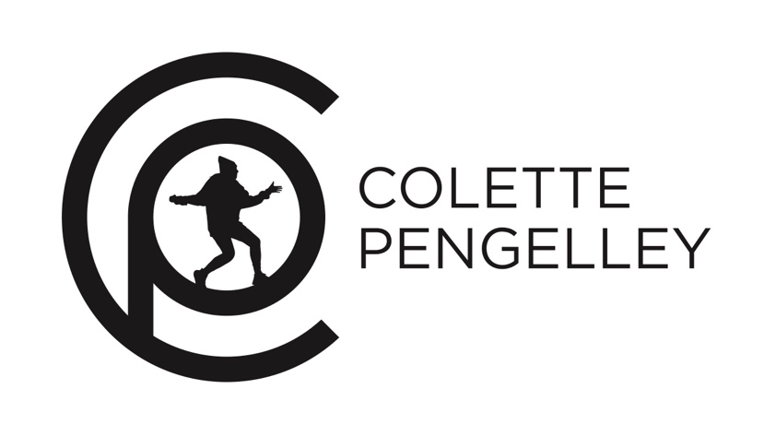

Colette Pengelley is an Australian dancer, performer, entertainer, choreographer and dance teacher. Colette began dancing when she was young, in 1998 Colette started taking Hip Hop classes and immediately had a passion for the Hip Hop style and then went onto train in many of the dance styles that fall under the Hip Hop umbrella such as popping, locking, breaking and funk. Colette completed her dance qualification and received her certificate 3 after two years of full-time study at the prestigious dance and performing arts school The Edge. Colette has been apart of such shows/performances as top 100 of So You Think You Can Dance, St Kilda Festival, Winter Beats, Australia’s Got Talent, Chinese New Year, performing/freestyling at corporate events such as Disney kids, The Australian Open and showcasing at several charity events. Most recently Colette put together her own show for Raw Australia 2019. Colette has been with Rewind Dance Company for approximately 10 years, Rewind placed first in Australian Hip Hop Championships 2011. Colette also teaches Hip Hop inspired choreography and other dance styles at such Australian dance schools as The Space, TDC and Passion Dance Studio and runs workshops at high schools and primary schools around her home city of Melbourne. Colette’s helped out at schools in Montana which involved her contributing to the dance team and the physical education department at Sentinel High School Missoula. Colette ran dance workshops and created choreography for competitions and performances at the Sentinel. Colette is really excited to bring that same passion and energy to Belgrade and Bozeman.

